Laura Krane
Mini- Lesson Reading
March 24th, 2015

Subject/Topic- Reading- Post- it’s to show thinking

Rationale- Students will be able to show what they are learning and thinking by using post-it notes while reading.

Standards: RL. 2.7 – Use information gained from the illustrations and words in a print or digital text to demonstrate understanding of its characters, setting, or plot.

Objectives: To be able to use post-its effectively.

Materials: Matilda (class read aloud), post-its, pencil, chart paper

Procedures

Engagement/Anticipatory Set
Teacher will call students over to the carpet and have them bring their class novel with them (Matilda). Teacher will ask them what they look for when they are reading. What are the things that they are thinking about when reading.

Mentor – teach and model
Teacher will start reading from where the class has left off in the class read aloud Matilda. When the teacher gets to a point where something is funny she will write on a post-it LOL- the teacher will keep reading until she finds other things that she is thinking about. As she does this she will create an anchor chart that includes all the different codes. After she is done reading she will go back to the pages with post-its and write what each post-it is about in a quick sentence.

Guided Practice
Have students go through the chapter that was just read and put post-its where they had a feeling. After giving students 5-10 minutes based on student response, call on a few students to see what they shared.

Independent Application
Students will be sent back to their seats and with a book of their choice, they will need to post-it feelings or what they were thinking when reading. Teacher will go around the room to make sure students are on task. If students seem to be struggling with this, teacher will pull them back to reteach the lesson.

Closure
Teacher will ask students to pair up with a buddy and share what they were thinking when they were independently reading.

Assessment
Students will need to complete this task while reading at home throughout the week. Teacher will check at the end of the week.

Differentiation

Students can read books of their own choosing. They will also all have their own copy of Matilda, this way if some students follow along better when having the book in front of them verses listening.

Chart:

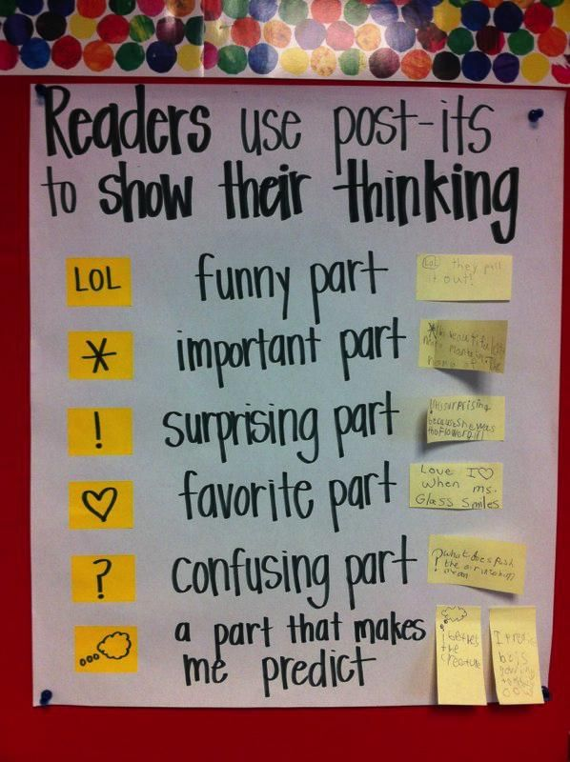

Mini Lesson – Writing

Subject/Topic- Writing- How to write a personal narrative

Rationale- Students will be able to create a personal narrative story that has all parts of a story.

Standards: W.2.3- Write narratives in which they recount a well-elaborated event or short sequence of events, include details to describe actions, thoughts, and feelings, use temporal words to signal event order, and provide a sense of closure.

Objectives: To be able to complete a personal narrative that includes all parts of a study.

Materials: chart paper, lined chart paper, markers. Paper for students

Procedures

Engagement/Anticipatory Set
Teacher will call students over to the carpet and read them a personal narrative about herself, which she has already written out on large lined chart paper. She will write on chart paper the words personal narrative. Under the word personal she will write about you and under narrative a story with events told in order.
Teacher will explain the parts of a narrative
- A story form your life ...One time I....
- Has a beginning, middle, and end.
- ZOOM in on a small moment. Stretch it out with details. Sensory (draw five senses) internal (feelings; happy sad, etc.)

Mentor – teach and model / Guided Practice
Teacher will go back and reread her own story. Have students point out what is included in the story that is a part of a personal narrative and what is missing and what should be added. Have students help add what is missing.

Independent Application
Students will be sent back to their seats and will need to start writing a personal narrative. Teacher will go around the room to make sure students are on task. If students seem to be struggling with this, teacher will pull them back to reteach the lesson.

Closure
Teacher will ask students to pair up with a buddy and share what they have written at this point. Partners will help each other pick out what is missing.

Assessment
Students will eventually need to complete a personal narrative for publishing.

